**Software Testing: - Assignment -4**

**1.Mention what are the categories of defects?**

* The different categories of defects are: -

1. Data Quality/Database Defects:

* Deals with improper handling of data in the database.
* Example :-
* Values not deleted/inserted into the database properly.
* Improper/wrong/null values inserted in place of the actual values.

1. Critical Functionality Defects:

* The occurrence of these Defects hampers the crucial Functionality of the application.
* Example :-
* Exceptions

1. Functionality Defects:

* These Defects affect the functionality of the application.
* Examples :-
* All JavaScript errors Buttons like Save, Delete, Cancel not performing their intended functions.
* A missing functionality (or) a feature not functioning the way it is intended to Continuous execution of loops.

1. Security Defects:

* Application security Defects generally involve improper handling of data sent from the user to the application. These Defects are the most severe and given highest priority for a fix.
* Examples :-
* Authentication: Accepting an invalid username/password.
* Authorization: Accessibility to pages though permission not given.

1. **User Interface Defects:**

* As the name suggests, the Defects deal with problems related to UI are usually considered less severe.
* **Examples:**
* Improper error/warning/UI messages.
* Spelling mistakes.
* Alignment problems.

**2.** **Difference between Priority and Severity**

|  |  |
| --- | --- |
| **Severity** | **Priority** |
| Severity indicates the potential impact a defect can have on the software's functionality. | Priority determines the sequence in which a defect should be fixed. |
| Severity is a measure of the overall impact a defect can have on the software. | Priority is a parameter that determines the order of fixing defects. |
| Severity is related to the quality standards. | Priority is related to the scheduling of defect resolution in the software. |
| The value of severity is objective. | The value of priority is subjective. |
| The value of Severity can change over time. | The value of Priority can change over time. |
| The severity level of a defect is typically determined by the testing engineer. | The priority level of a defect is typically determined by the product manager. |
| There are five types of Severities: Cosmetic, Minor, Moderate, Major, and Critical. | There are three types of Priorities: High, Medium, and Low. |

**3.What is Bug Life Cycle?**

* The duration or time span between the first-time defects is found and the time that it is closed successfully, rejected, postponed or deferred is called as ‘Bug Life Cycle’.

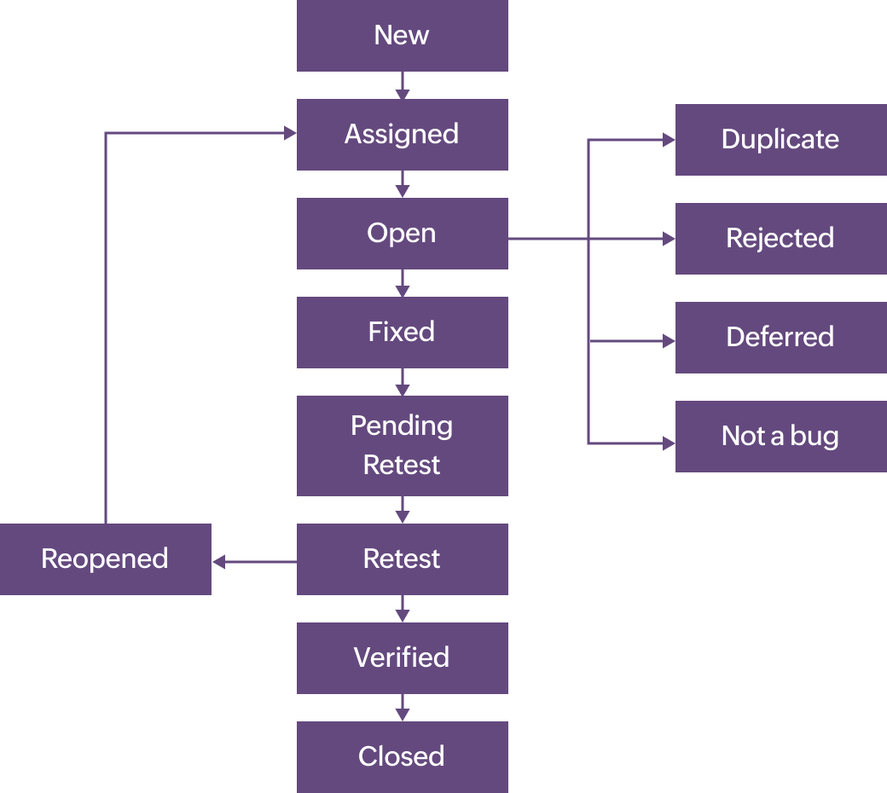

**4. What is priority?**

* Priority is Relative and Business-Focused. Priority defines the order in which we should resolve a defect. Should we fix it now, or can it wait? This priority status is set by the tester to the developer mentioning the time frame to fix the defect.

1. **What is severity?**

* Severity is absolute and Customer-Focused. It is the extent to which the defect can affect the software. In other words it defines the impact that a given defect has on the system.

**6.Bug categories are…**

* **Bug Categories are as follow:-**

1. **Data Quality/Database Bugs**: Deals with improper handling of data in the database.

**Example :-**

* Values not deleted/inserted into the database properly.
* Improper/wrong/null values inserted in place of the actual values.

**2.Critical Functionality Bugs:** The occurrence of these bugs hampers the crucial Functionality of the application.

**Example :-**

* Exceptions

**3.Functionality Bugs:** These Bugs affect the functionality of the application.

**Examples :-**

* All JavaScript errors
* Buttons like Save, Delete, Cancel not performing their intended functions.
* A missing functionality (or) a feature not functioning the way it is intended to Continuous execution of loops.

**4. Security Bugs:** Application security Bugs generally involve improper handling of data sent from the user to the application. These Bugs are the most severe and given highest priority for a fix.

**Examples :-**

* Authentication: Accepting an invalid username/password.
* Authorization: Accessibility to pages though permission not given.

**5.User Interface Bugs:** As the name suggests, the bugs deal with problems related to UI are usually considered less severe.

**Examples:**

* Improper error/warning/UI messages.
* Spelling mistakes.
* Alignment problems

**7.Advantage of Bugzilla .**

* Bugzilla is an open-source issue/bug tracking system that allows developers effectively to keep track of outstanding problems with their product. It is written in Perl and uses MYSQL database.
* Below are advantages of Bugzilla :

1. Key features of Bugzilla includes

2. Advanced search capabilities

3. E-mail Notifications

4. Modify/file Bugs by e-mail

5. Time tracking

6. Strong security

7. Customization

8. Localization